Samuel Nwuha CSC 322

November 25, 2022

Checkpoint 1.1-1.2

Activity 3

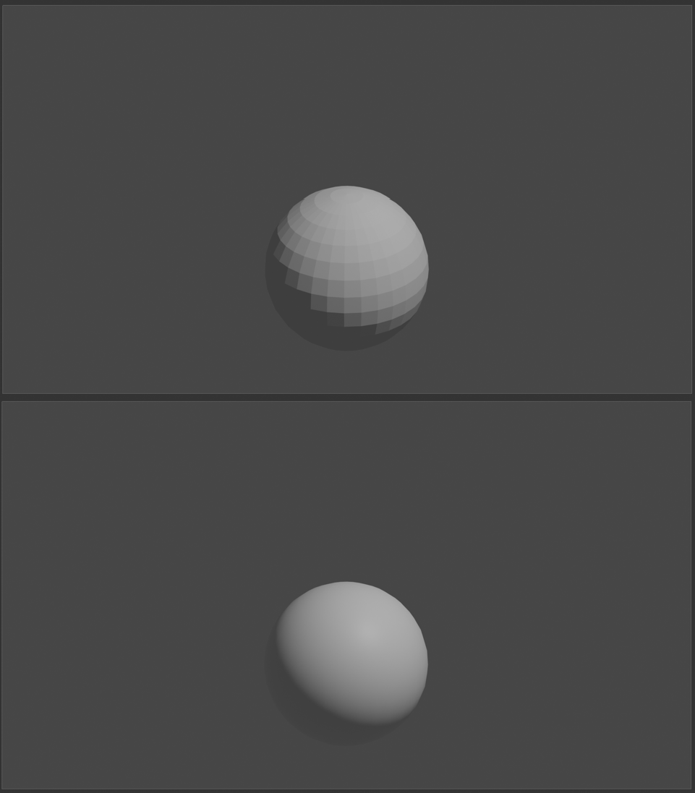

Checkpoint 1.3: In the smooth shading, the edges are practically smoothed out.

Checkpoint 1.4-1.5:

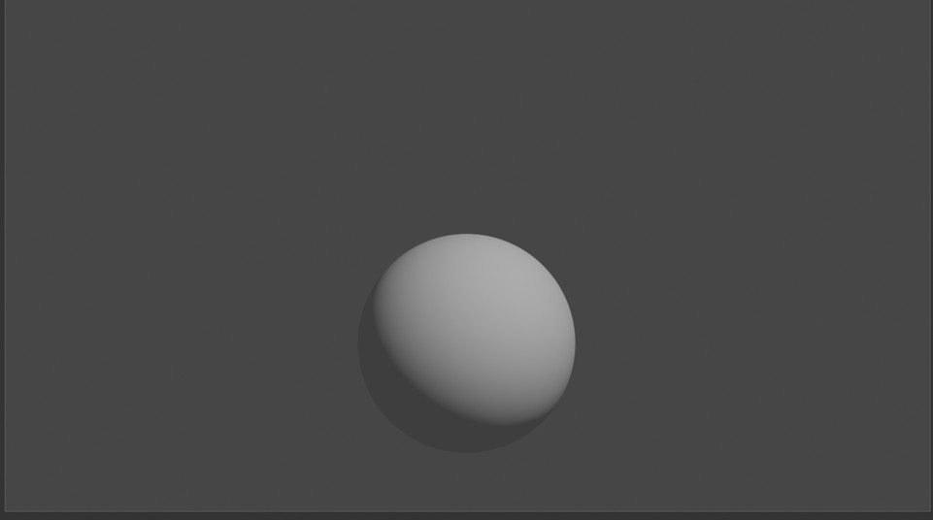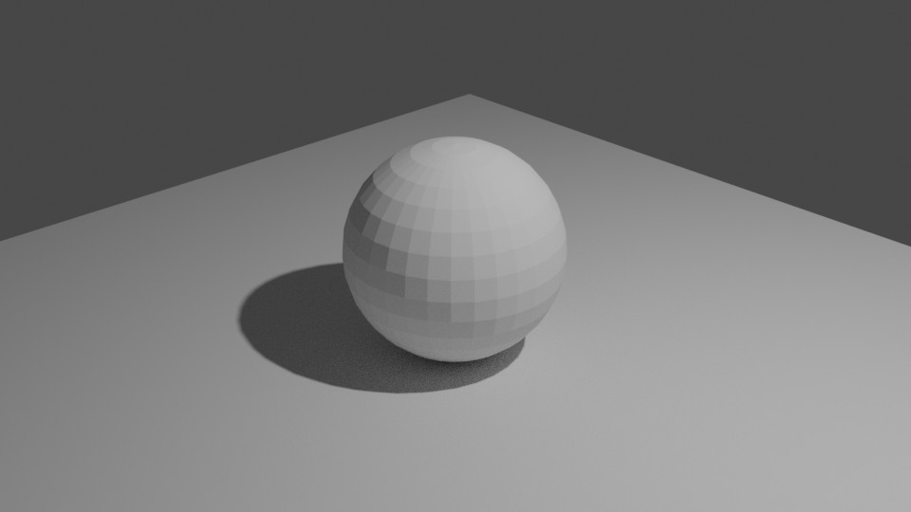

Checkpoint 1.6: With smooth shading, the entire object is smooth, but with with subdivision, although edges are still visible, they aren’t as noticeable. Employing both will increase the efficiency of the scene.

Checkpoint 2.1

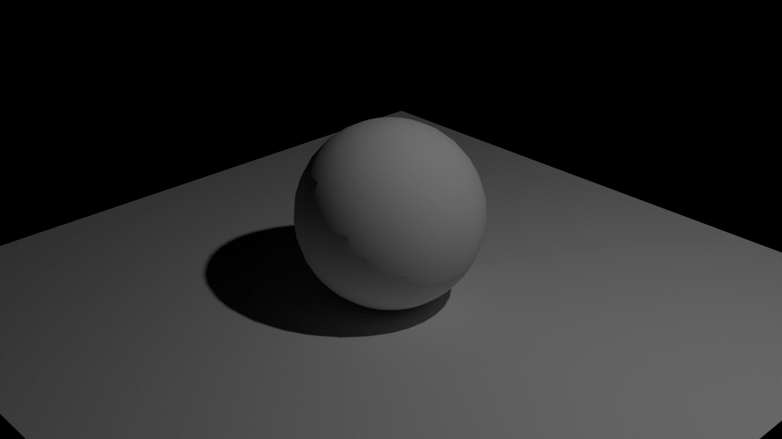

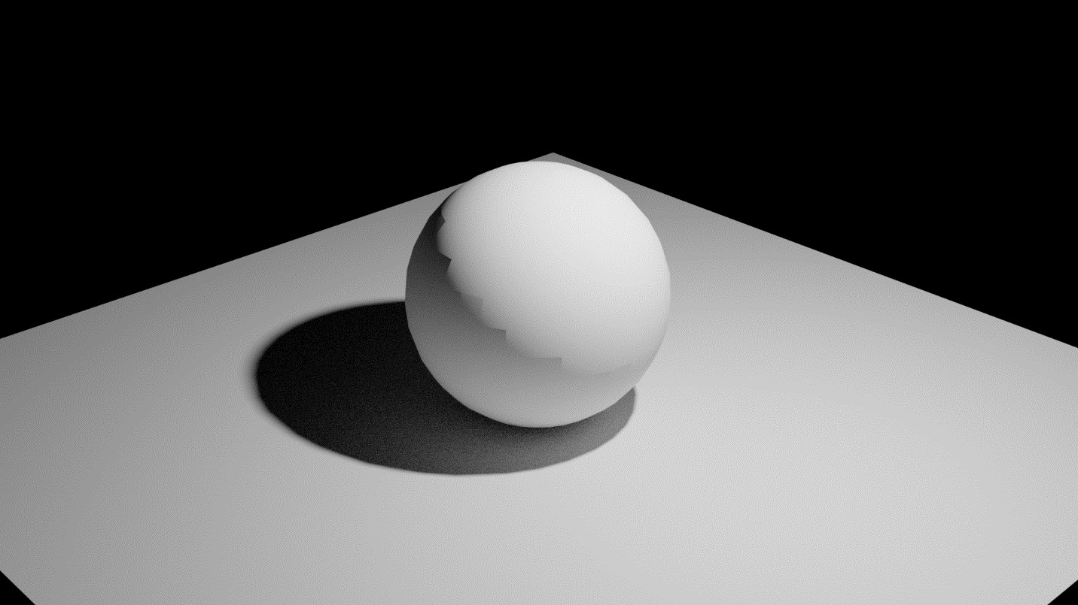Checkpoint 2.2: The higher the light power is, the brighter the image will be. Checkpoint 2.3:

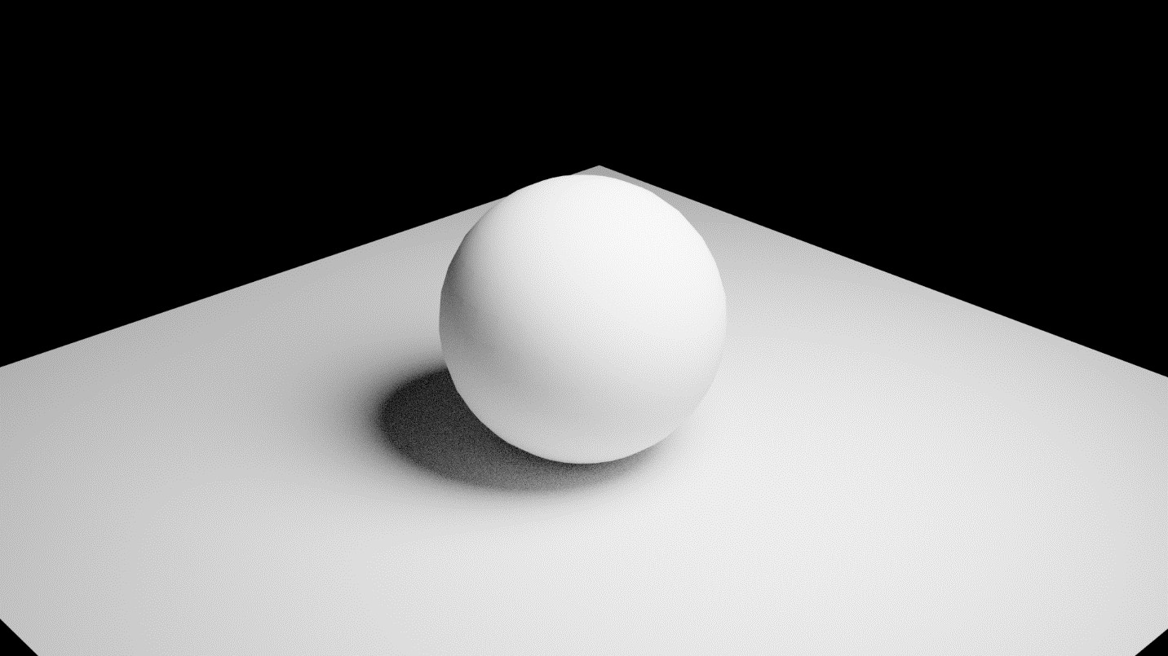Checkpoint 2.4: The closer the light, the brighter the image seems Checkpoint 2.5:

Checkpoint 2.6: The area light puts emits more light onto the plane and wall

Checkpoint 3:

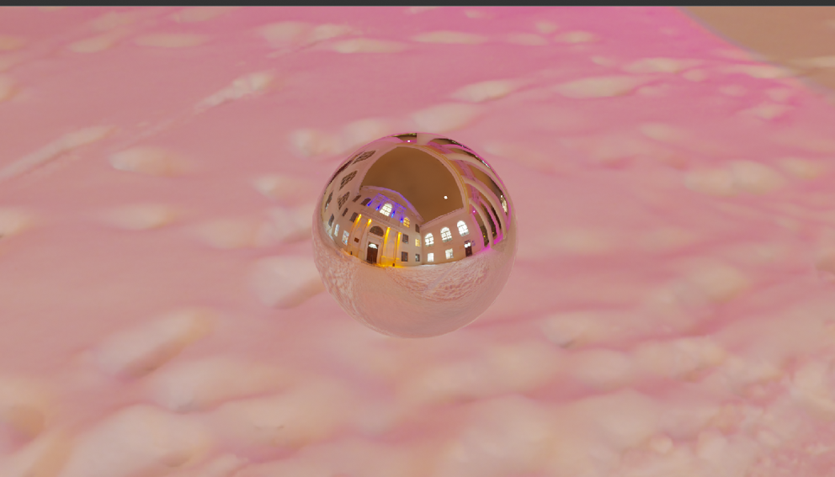

Checkpoint 4:

 

 

